APPENDIX A

SECTION B PART 1 - SERVICE SPECIFICATIONS

Service Specification No. | V7– December 2015
Service | Community Nursing/Therapies Southport and Formby
Commissioner Lead
Provider Lead
Period
Date of Review

Population Needs

National/local context and evidence base

The number of people in Britain aged over 85 increased from 416,000 in 1971 to over 1.1 million in 2009, and is expected to reach 2.6 million in 2021. It is worth noting, however, that increasing life expectancy has been accompanied by increasing healthy life expectancy, although the length of unhealthy life has increased overall – in other words, length of healthy life has not increased as much as total length of life. Analysis of the drivers of cost pressures facing the NHS over the coming years suggests the growth in demand for care because of long term conditions is at least equal to, if not more than, the pressure from a growing and ageing population in and of itself. And on top of this pressure from the growth in demand, there will be funding pressures too from the rising costs of providing healthcare, such as costs of drugs and technology.

Older people use health and care services heavily. People over 65 consult general practitioners (GPs) generally five times more than the average for the population. They account for 62% of total bed days in hospitals in England, 68% of emergency bed days, and 80% of deaths in hospital .

The average age of people in hospital is over 80. More than three quarters of people receiving care in registered residential and nursing accommodation in England funded by councils are aged 65 and over, with 43% aged 85 and over. Four of five people receiving community based home-care services are aged 65 or over.

The number of people aged 65 and over in England with care needs, such as, washing and dressing, has been projected to growfrom2.5 million in 2010 to 4.1 million in 2030 .

In common with other areas of the country, the changes in the population demographics are impacting on the demand for health and social care support. Locally, although the population size is remaining stable, the proportion of the population aged over 75 years of age is predicted to increase significantly in the coming years, and causing a subsequent increase demand on the available resources.

Already the increased number of elderly patients within the localities is manifested within the care home sector. The combined population of West Lancashire and Southport & Formby is 225,000; in West Lancashire, Southport and Formby there is one care home bed for 69 people as opposed to a national figure of one bed to 150 people.

In Southport and Formby we know:
- Our population is ageing. In 2011 there were estimated to be more than 26,000 residents aged 65+ and this is expected to increase by as much as 10% within the next five years, and there are 22,100 residents aged under 18 in Southport and Formby – roughly equal to the number of over 67 year olds.
- Our diversity. In recent years, there have been growing communities of international workers in and around Southport. Whilst no definitive figures exist, sources indicate there could be as many as 2,000 international workers, 300 school age children and 600 partners/other family members.
- Our life expectancy. Life expectancy is similar to the national average at 78.1 years for males and 82.4 for females (2011 estimates). However, there are differences in life expectancy within the Consortia of over 7 years for both sexes.
- In terms of deprivation, the least deprived areas cover large parts of Formby, areas in Hillside and a pocket in Churchtown. The most deprived areas cover Southport town centre, Blowick and pockets in Ainsdale and Kew.

The Sefton JSNA is attached for consideration of more detail

In addition to the increased demand arising from changes to the demographic profile of populations, trend analysis shows how changes in policy, behaviour and patient choice is driving up the use of urgent care and hospital services. A report by the National Audit Office in 2013 analysed the trends in emergency admissions and concluded the following:
- The increase in emergency admissions over the last 15 years has come almost entirely from patients being admitted from major accident and emergency (A&E) departments who have a short hospital stay once admitted. Over the last 15 years, short stay (less than two days) admissions have increased by 124%, whereas long-stay (two days or longer) admissions have only increased by 14%.
- More patients who are attending major A&E departments are now being admitted. In 2012-13, over a quarter of all patients attending major A&E departments were admitted to hospital, up from 19% in 2003-04. This increase accounts for three-quarters of the rise in emergency admissions through major A&E departments, while an increase in the number of people attending major A&E departments accounts for the remaining quarter.
- The causes of the increase in emergency admissions include systemic issues, policy changes, changing medical practices, demographic changes and the fact that A&E departments are under increasing pressure.

The effective management of the flow of patients through the health system is at the heart of reducing unnecessary emergency admissions and managing those patients who are admitted. For example:
- Primary, community and social care can reduce admissions through improving management of long-term conditions
- Ambulance services can reduce conveyance rates to accident and emergency (A&E) departments, for example by conveying patients to a wider range of care destinations including community services
- Hospitals can reduce emergency admissions by ensuring prompt initial senior clinical assessment, prompt access to diagnostics and specialist medical opinion; and
- Once admitted, hospitals working with community and social care services can ensure that patients stay no longer than is necessary and are discharged promptly.

Our ultimate aim is to improve the outcomes and experiences of individuals and communities through the delivery of cost effective, integrated seamless care, support and treatment. To achieve this we will work together, effectively engaging individuals, communities and our stakeholders to transform our local health and care services to:
- Better co-ordinate, plan and deliver more personalised care and support to people living with long-term conditions and the frail elderly, in order to improve their quality of life and health outcomes
- Develop local community services to offer better access to care and support across the 7 day week.
- Support the optimal delivery of elective care; utilising community support, where appropriate, to ensure individuals stay in hospital is minimised.
- Design an urgent care system that delivers integrated services outside of hospital for people whose physical or mental health need for urgent care can be met by responsive advice, support and treatment closer to home
- Ensure that end to end integrated care pathways in and out of hospital run smoothly, ensuring evidence based care is consistently and equitably delivered to all individuals and communities in support of seamless care and the best patient experience possible.
- Empower communities and offer greater choice to individuals, by providing transparent information about the range and quality of health and care services available
- Keep Sefton residents well for longer in our communities, reduce inequalities and put greater emphasis on prevention of ill health and the mobilisation of community and personal assets to support self-care

This service specification should be linked to other services for example:
- Public Health
- Workforce Planning
- Community adult health services
- Cancer
- Learning Disabilities
- Dementia
- Continuing Care
- Urgent and emergency care
- Primary care
- Mental Health

Outcomes

NHS Outcomes Framework Domains & Indicators

Domain 1 | Preventing people from dying prematurely
Domain 2 | Enhancing quality of life for people with long-term conditions
Domain 3 | Helping people to recover from episodes of ill-health or following injury
Domain 4 | Ensuring people have a positive experience of care
Domain 5 | Treating and caring for people in safe environment and protecting them from avoidable harm

Local defined outcomes

National guidance suggests that selected hospital services should be moved from an acute setting into the community, this includes delivering care closer to home, reducing hospital admissions and re-admissions, reducing average length of stay (LOS), increasing patient choice and satisfaction, addressing the health needs of an ageing population, early intervention and disease prevention strategies.

Southport and Formby CCG has identified three main priorities:
- Frail Elderly: To support the frail elderly, with long term conditions, to optimise self-care based in the community or home setting, while preventing unnecessary and unplanned admission to hospital.
- Unplanned Care: To support patients of all ages to manage their healthcare needs at home or in the community setting, while preventing unnecessary and unplanned admission to hospital.
- Primary Care Transformation: To support the healthcare needs of the population through enhanced primary and community care services, supporting self-care and enabling appropriate intervention at home or in the community and preventing unnecessary and unplanned admission to hospital.

While these three strategic priorities are aligned with the major health needs and issues for the population of Sefton, there is recognition that other significant areas also need to be addressed within the strategic and operational plans

For those approaching the end of life; all care should be provided in usual place of residence, or preferred place of care as far as possible, thereby ensuring meeting people’ s wishes and preferences, preferred place of care and supporting families to cope before and after the death. Place of care and death data and attention to death in usual place of residence (UPR) is a Key Performance Indicator for EOL care. It focuses on place of death, namely 'usual place of residence', as a proxy marker for quality. It is based on death registration information collected by the Office for National Statistics (ONS). The indicator is produced quarterly on a rolling 12-month basis for all primary care organisations in England.

Scope

Aims and objectives of service

The ultimate purpose of community nursing and therapy teams is to work collaboratively in providing safe and effective holistic care to people in or near their home, (e.g. treatment rooms) enabling people to make choices, self-manage, maintain control over their quality of life and be cared for in their usual place of residence (UPR) or preferred place of care (PPC) where possible for both planned care and unplanned care episodes.

The Framework for Commissioning Community Nursing advises of eight components of care:

Service description

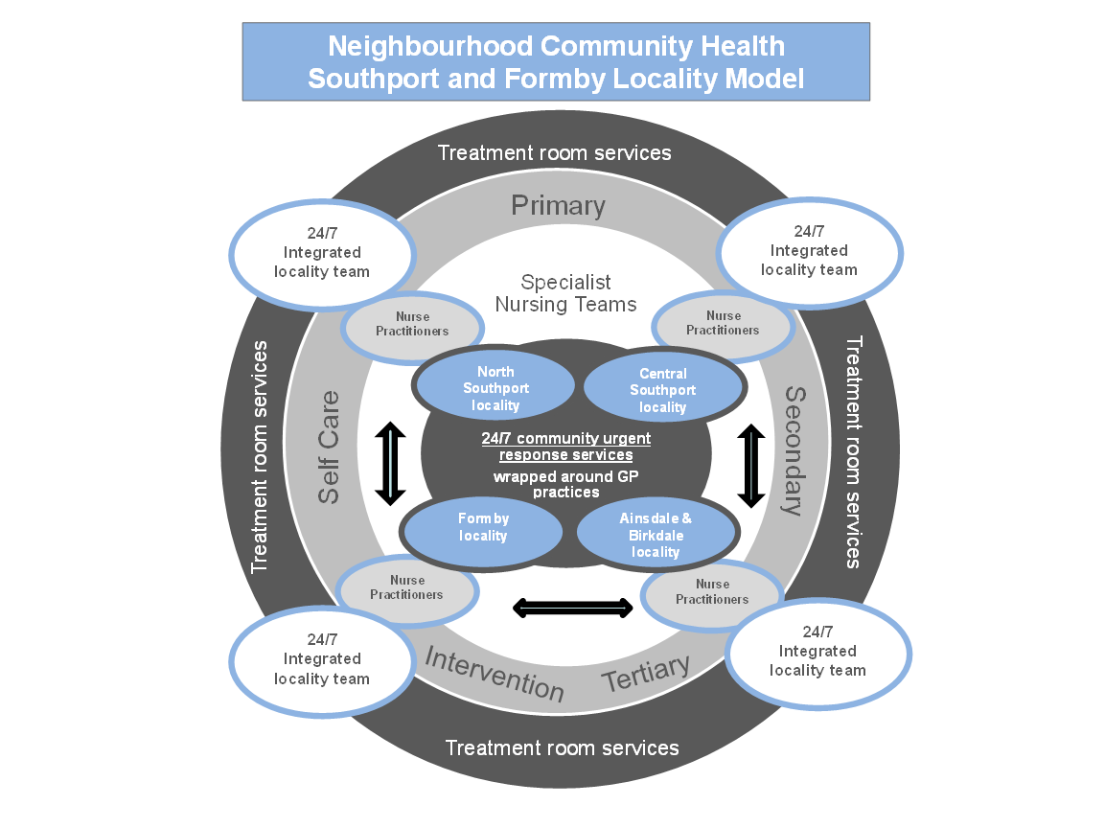

Referrals will be made via a single responsive point of access, (locality focused) by which referrers will only be required to make one contact either by telephone email etc. depending on service model.

Services will be developed and based around existing 4 primary care localities and natural geographies with a multidisciplinary team approach. These teams will need to work with specialist services – both community and hospital based to offer patients a much more complete and less fragmented service.

The approach will require locality based community teams with a shared set of skills and will include some staff with more specialist knowledge to ensure the adult population of Southport and Formby are provided with a community service that provides:
- All aspects of nursing and therapy care for patients with acute and chronic illness
- Teaching self-care procedures to enable patients to manage their own health needs
- Preventing health complications associated with immobility, disability or existing illness
- Palliative and terminal care
- Integrated Care with other health and social care providers
- offering 24/7 services as standard and include working in an integrated fashion with both generic and specialist teams supported by & fully integrated with consultant led inpatient and outpatient specialist services
- Working with mental health services to promote equal access to care and to ensure that the care of people identified with dementia is undertaken in unison with specialist dementia services.
- Working to meet the physical needs of patients with mental health and dementia at all stages of those respective models
- Psychological support/supervision will be in place to support patients, families, carers and staff
- Staff delivering services must receive mandatory training and be compliant with the Mental Capacity Act
- Services will use locally agreed nursing care plan for the dying patient
- Promote the development and recording of Advance Care Planning using locally agreed documentation
- (including DNACPR) (see model below) have an understanding of the development of and implications of a DNACPR statement.

Prescribing or prescribing recommendations will be in line with local and national guidance supported by the Commissioner. The provider will have antimicrobial stewardship programme (https://www.nice.org.uk/guidance/ng15)

The service needs to provide a rapid response to avoid admission and be fully integrated to expedite discharge of patients from hospital utilizing a holistic approach to patient care. There is a requirement that all services will work cohesively to ensure the patients care is seamless and of a high quality thus facilitating timely and safe management at home and discharge from hospital. Services working in an integrated approach include: Mental Health, Social Care, Specialist Palliative and End of Life Service, Voluntary Services, Urgent Care Team, NWAS and any other relevant services deemed necessary to support the patient and their families/carer’s

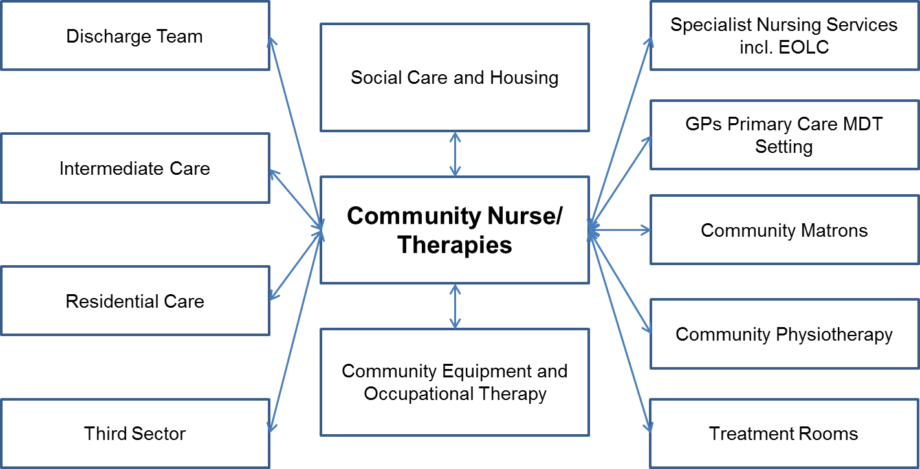

Teams

Case Management

Case management is central for the management of people with long term conditions and traditionally the roll of community matrons.

In this type of case management, community nurse leaders will:
- Use data to actively seek out patients who will benefit
- Combine high level assessment of physical, mental health, dementia and social care needs
- Review medication and prescribe medicines via independent and
- Provide clinical care and health promoting interventions
- Co-ordinate inputs from all other agencies, ensuring all needs are met
- Teach and educate patients and their carers about warning signs of complications or crisis
- Provide information so patients and families can make choices about current and future care needs
- Are highly visible to patients and their families and carers, and are seen by them as being in charge of their care
- Are seen by colleagues across all agencies as having the key role for patients with very high intensity needs.

The principle of this particular model of case management is that there is one person who acts as both provider and procurer of care and takes responsibility for ensuring all health and social care needs are met, so that the patient's condition stays as stable as possible and wellbeing is increased. While community nurse leaders will focus on patients with very intensive needs, other patients with long term conditions may continue to receive active case management from a range of professionals, like physiotherapists and occupational therapists, whose skills best suit their needs.

Case management will:
- Help to prevent unnecessary admissions to hospital
- Reduce length of stay of necessary hospital admissions
- Improve outcomes for patients
- Integrate all elements of care
- Improve patients' ability to function and their quality of life
- Help patients and their families plan for the future
- Promote and support integrated care across all pathways based on need
- Increase choice for patients
- Enable patients to remain in their homes and communities
- Improve end of life care

End of Life Co-coordination

- The role of the End of Life Coordinator will be responsible for the coordination of palliative and EOL care 24/7 across all localities and will include, but not exclusively:
- Liaison between generalist and specialist teams
- Be the first contact for the Discharge Planning teams
- Point of contact for palliative and EOL patients in the secondary care, tertiary care setting including AED
- Support integrated working with the Urgent Care teams for admissions avoidance
- Work closely with Continuing Health Care teams to ensure effective management of fast track referrals for expedient implementation
- Provide co-ordination of education for specialist and generalist health care professionals and health care assistants

3.3.3 Palliative Care

People who face progressive life-limiting illness and co-existing comorbidities, as well as those important to them, require different levels of health and social care at different points in their illness. Apart from care and treatment that is specific to their underlying condition(s), they are likely to have end of life (EOL) and specialist palliative care (SPC) needs that are often referred to as ‘end of life care’, especially as they approach the last year(s) of their lives. Throughout the trajectory of their illness, sometimes episodically, sometimes for prolonged periods, they may require expert assessment, advice, care and support from professionals who specialise in palliative care. These professional should work as part of multi professional teams, providing the service directly to the person and those important to them and/or supporting others to do so.

Specialist level palliative care services are therefore an integral part of resourcing care for these people and are delivered through a range of providers with the specialist resources to provide the required services, including services for the homeless, those in prison and people within mental health care settings. Many aspects of provision will require cross-organisational collaboration and cooperation to achieve the services in a way that is effective, efficient, sustainable and supports ongoing quality improvement.

Input from SPC services to the care of a person must be based on the needs of the person and not the illness they have. They work with the person to develop a plan of care tailored to the person, including where the care is delivered. This plan is regularly reviewed according to the changing needs of the person to ensure that care is provided by the most appropriate health or social care professional and this may be facilitated through shared services agreements. The main components of specialist level palliative care provision for the person include, but are not limited to:
- the assessment and management of physical, psychological, social and spiritual symptoms to mitigate distress,
- analysis of complex clinical decisions-making problems where medical and personal interests are finely balanced by applying relevant ethical and legal reasoning alongside clinical assessment
- provide care and support to those important to the person receiving care, including bereavement care

A specialist level palliative care service is usually provided in three main ways:
I. Specialist level palliative care liaison work to support the person's care by their usual caring team: in hospital, in the community and at some day care facilities, a specialist assessment will lead to recommendations for care that will be carried out by the usual caring team. The person's needs should be reviewed at an MDT meeting constituted to consider all specialist-level aspects of their care on a regular basis, as determined by their needs, and also by a contribution from a palliative care specialist into care review and planning meetings held by the caring team.
II. Specialist level in-patient palliative care: this may be in beds in a palliative care unit in hospital or hospice, or may be delivered in the person's usual place of residence in some rural localities. The person's needs are assessed and their care is planned and delivered by medical, nursing and other care staff who specialise in palliative care. Arrangements should be in place for specialist support to the wider care team 24/7. The service should have access to all essential specialists to constitute a specialist palliative care team.
III. Specialist level out-patient services: people may have their needs assessed and their care planned by palliative care specialists working in Out Patient clinics or Day Centres in a variety of settings. Specialist level palliative care out-patient clinics and therapies may be provided by clinicians specialising in palliative care that include medical, nursing, AHP, and psychological or spiritual support interventions, or complex social support issues, according to the needs of the person, people important to them and their carers.

Many staff currently working within a specialist level palliative care service hold joint NHS and voluntary sector contracts, or SLAs, which cover services in the community, residential facilities, hospices and acute hospitals simultaneously. Formal arrangements should be in place so that they are able to come together to provide a holistic service to a person with specialist level palliative care needs following referral and assessment.

The SPC services also have a lead role in developing and contributing to the delivery of education, training and continuing professional development regarding best practice in palliative and end of life care to the generalist workforce. It is also important that the evidence base for best practice is maintained through their contribution to Clinical Research Networks and National Audits by participating in a rolling programme of evaluation using validated patient and colleague-centred outcome measures.

Funding for specialist level palliative care services comes from both the NHS and voluntary sectors through charitable funds, and the flexible cross organisational nature of these arrangements must be considered and formalised locally.

The underpinning evidence base for this specification includes:
- National End of Life Care Strategy (2008)
- NICE Quality Standard for End of Life Care for Adults (Nov 2011/2015)
- One Chance to Get it Right: Improving people’s experience of care in last few days and hours of life (June 2014). Leadership Alliance for the Care of Dying People
- Ambitions for Palliative and End of Life Care: A national framework for local action 2015- 2020 (2015)

It is important that where EOL and SPC services are working well in an integrated fashion and across boundaries, care should be taken not to de-stabilise and disintegrate seamless services.

Place of death data and attention to death in usual place of residence (UPR) is a Key Performance Indicator for EOL care. It focuses on place of death, namely 'usual place of residence', as a proxy marker for quality. It is based on death registration information collected by the Office for National Statistics (ONS). The indicator is produced quarterly on a rolling 12-month basis for all primary care organisations in England.

Please refer to:
http://www.dc.nihr.ac.uk/__data/assets/file/0005/157037/Better-endings-FINAL-DH-single-page.pdf

Community Nursing

Community nurses will include:
- Qualified nurses with a graduate level education and specialist practitioner qualification recordable with the Nursing and Midwifery Council who participate in the re-validation process
- Non-qualified nurses with relevant training and NVQ as required

By community nursing teams, we mean:
‘A team led by a senior qualified nurse supported by registered nurses, health care assistants and support staff.’

By community nursing services, we mean:
‘Care provided in a variety of community settings including care homes by community nursing teams including a wide range of care, for example, supporting patients with long-term conditions in their own homes and providing complex palliative care.’

Comprehensive high quality community nursing services have the potential to reduce use of hospital sector and residential social care.

Community nursing work remains both preventive and supportive. It can also be highly technical, risk-taking, intensive and practical. The nature of the work is unpredictable and changeable; it requires community nurses to be responsive, flexible and adaptable. There are inherent contradictions: community nursing is autonomous, but highly dependent on its networks and contacts; it is responsive to demand, but has to be proactive in managing both long-term and short-term patient pathways.

Community nursing should be seen as a body of specialist knowledge and practical skills that can contribute to many of these pathways – particularly acute care in the home, care of long term conditions and palliative care – as part of an integrated service designed around patient needs.

The patients that community nurses care for will be categorised by the nature of their needs: regular; short-term (which may mean very intensive support); limited involvement (assessment only); phlebotomy only; or additional – including those who attend clinics, need annual flu jabs, or receive proactive ‘outreach’ services.

The three main elements of the community nurse role, respondents to the Queen Nursing Institute and British Journal of Community Nursing survey (QNI/BJC) offered these summaries:
- ‘Holistic assessment of patients and their families
- Enabling complex care to be organised and provided at home
- Working with patients, multi-disciplinary team and families to provide unique care for individuals.’

And:
- ‘Managing complex healthcare within patients’ own home
- Liaising with many different services.’

Community Nurse skills should include:
- Clinical skills: holistic assessment and holistic care; wound care; palliative care; ability to cope with a range of illnesses; managing complex healthcare within the home; prescribing
- Management skills: delivery of care based on expressed need; ability to work autonomously; managing diversity; being flexible and adapting to changing situations; caseload management and care co-ordination (or, as a survey respondent summarised: ‘communication, organisation, observation’)
- Leadership skills: clinical leadership; providing education to staff and patients:
- Strategic skills: knowledge of the local community, need and current services; being the patient’s advocate.

Community Nurses will work with specialist nurses in areas such as wound care, continence, palliative care and specific long term conditions who visit patients at home.

Treatment room nursing care provision:

No national service model or definition currently exists for Treatment Room Services, evident by the wide range of service models and interventions in existence. However, in accessing information about a wide range of similar services they can be defined as:

‘Nursing services providing an agreed range of core clinical interventions in a local clinical setting to non-housebound patients, typically these can include practical hands on treatments and interventions such as injections, leg ulcer management, wound management, dressings and specimen collection’.

This would seem a reasonable definition to use in considering treatment room models.
The commissioner would welcome proposed development of treatment room services to include an element of minor injury care and extended hours of provision.

Admission Avoidance and Transition from Hospital Scheme (Community Intermediate Care, discharge planning and emergency response teams)

The Community Intermediate Care service will be a multi-disciplinary team (a combined team of professionals from the awarded community services provider, Sefton Council, Mersey Care and Community, voluntary and faith), which provides both in-reach or ‘pull’ approach to hospital discharges and acts as an admission avoidance scheme for patients with frailty who may need additional support to remain at their normal place of residence, where appropriate the service will also deliver a proactive approach to optimising health to delay the impact of frailty.

Closely aligned to other out of hours and nursing community services, the Community Intermediate Care service will support delivery of a 24/7 urgent response to patients and carers in a health or social care crisis to avoid an acute admission and to deliver care closer to home.

The Community Intermediate Care service will also act as a single point of access for all community rehabilitation referrals to ensure that patients are treated by the right service at the right time, stabilising patient need / risk and transferring patients to other community rehabilitation services when appropriate to ensure optimal outcomes for patient rehabilitation.

The full specification for this service is the “Admission Avoidance and Transition from Hospital Scheme Service Specification”.

Community Adult Rehabilitation Service

The purpose of the Community Adult Rehabilitation Service is to provide therapeutic assessment, diagnosis treatment, advice, equipment and support to adults with a wide range of conditions to promote maximum recovery and independence or to maintain deteriorating conditions as long as possible. The service also provides practical advice and support to patients’ families and carers.

The service will be delivered by therapists with sufficient neurological rehabilitation knowledge to provide specialist assessment, treatment, advice and support where appropriate, for patients who have had a stroke or present with a neurological condition. This service follows discharge from the stroke unit or neurological unit as part of an organised, supported discharge and longer term support to ensure seamless transfer into the community. This is provided at sufficient intensity, according to individual patients’ needs. This service is also provided to neurological patients within the community who require re-assessment, treatment, further rehabilitation, advice and support.

As part of a multidisciplinary team, the Speech and Language Therapists within this team will provide support to adults with acquired communication and/or swallowing problems caused by neurological conditions (e.g. stroke, multiple sclerosis, parkinson’s disease, motor neurone disease).

Community therapists will support Sefton council in assessment of clients requesting Blue Badge parking permits.

The full specification for this service is the “Community Adult Rehabilitation Service Specification”.

Palliative Care

Specialist palliative care is defined as the active total care of patients with progressive, far advanced disease and limited prognosis, and their families and carers, by a multi-professional team who have undergone recognized specialist palliative care training. It provides physical, psychological, social and spiritual support, and will involve practitioners with a broad mix of skills, including medical and nursing, social work, pastoral/spiritual care, physiotherapy, occupational therapy, pharmacy and related specialities.
(National Council for Hospice and Specialist Palliative Care Services 2000)

Patients admitted for specialist palliative care intervention and support should be admitted under the care of a Consultant in Palliative Medicine who is on the specialist register for palliative medicine and who is an active member of the specialist palliative care MDT. In addition to the named principal clinical management by a Consultant in Palliative Medicine patients should have access to specialist palliative care support through the specialist multi professional team.
(MCCN Palliative Care Strategy 2007-2010)

Phlebotomy

The purpose of the Community Phlebotomy service is to support the delivery of primary and community based services. Community phlebotomy is delivered in two defined areas: community based services for ambulant patients and domiciliary phlebotomy for those who cannot access community based services. The most appropriate staff model should be used to deliver this service based on competency and skills.

Tissue Viability

The Tissue Viability Service aims to assist in the maintenance of healthy, intact skin. Skin may be prone to damage for many different reasons including pressure ulcers, leg ulcers, burns, surgical wounds and varying skin conditions. The Tissue Viability Service assist in providing clinical information and treatments relating to the maintenance of skin and wound healing and will provide specialist and evidence based tissue viability advice regarding management and treatment of all patients treated in any setting with problematic or complex tissue viability needs. The role also includes teaching and demonstrating and maintaining specialist wound healing equipment as required.

The service is mainly for healthcare and allied professionals working in both the NHS and private agencies such as nursing homes, to access information and request assessment by the Service. It is anticipated that there will be the need for flexibility for home visits and attend care homes and clinics such as treatment room services.

The working hours of the service will be determined by the need of the population and agreed by the commissioner and provider.

Diabetes Specialist Nursing

The community diabetes specialist nurses will provide a comprehensive high quality integrated community based specialist nurse led service for adult patients with diabetes, and to support families and carers of patients with diabetes, in accordance with NICE guidelines.
They will deliver specialist Community Diabetes Clinics within Southport and Formby providing early access to interdependent specialties within the family of cardiovascular disease to reduce the risk of complications associated with diabetes.
Community diabetes specialist nurses will provide timely and accessible expertise to evidence based clinical therapy and education to enable patients to achieve greater levels of self-care and self-management including improved access to essential specialist intervention for the hard to reach population.
The community diabetes specialist nurses will provide timely and accessible support to health professionals who will deliver better patient care, through improved relationships and education with general practice.

Services Provided

Community Nurses should provide/oversee but not exclusively:
- Advice and Support
- Phlebotomy
- Injection
- Wound Care including treatment room provision and leg ulcer care
- Monitoring/Screening
- Continence management
- Pain Control
- Pressure area care
- Administration of medicines
- Bowel care
- Peg feeding
- Equipment
- General nursing care
- Skin Care
- Prescribing
- Urinary catheterisation
- End of Life care
- Cancer chemotherapy
- Medication reviews
- Risk assessment
- Inter-agency referral
- Education
- Management and treatment of lymphoedema
- immunisation’s and vaccinations (e.g. flu Pneumovax and Shingles)
- Safeguarding of adults in Care homes
- Care of leg ulcers
- Review of patients with CHC funded care

Population covered

Aged 16+ and registered with a Southport and Formby GP practice.

Southport and Formby CCG-map

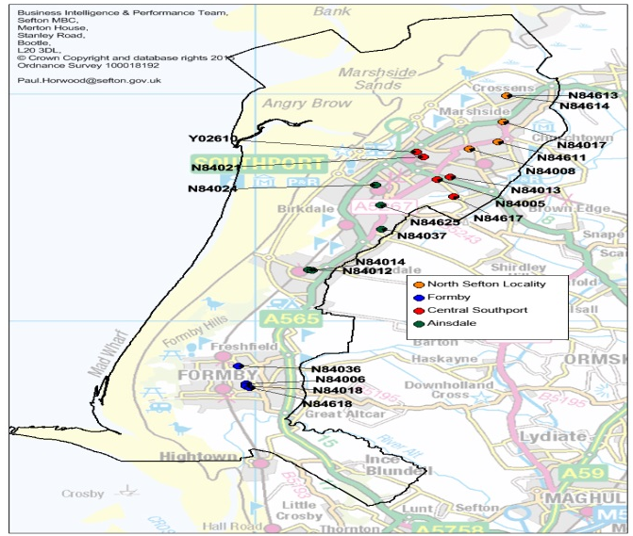

Any acceptance and exclusion criteria and thresholds

Referrals for adults aged 16+ registered with a North GP Practice and meeting the criteria should be accepted by the appropriate provider.

Referrals for under 16 years should be signposted to appropriate services.

Referrals not meeting the criteria will always be signposted to the appropriate services

Interdependence with other services/providers

- Care Homes
- Local Authority
- Macmillan
- IM&T Mersey
- Primary Care
- Secondary Care
- Tertiary Care
- Community Voluntary Services
- Out of Hours Services
- Ambulance Transport Providers
- Mental Health and Dementia Specialist nursing teams aligned with secondary providers
- Equipment Services
- Continuing Health Care
- Urgent Care Teams
- TRANSFORM
- Queenscourt Hospice
- Pharmacists Support
- Bereavement support services
- Other agencies
- Public Health providers of services for individuals with long term conditions
- Other appropriate organisations

Applicable Service Standards

Applicable national standards (e.g. NICE)
- Framework for Commissioning Community Nursing – NHS England Oct 2015
- Ambitions for End of Life Care 2015-2020
- Actions for EOL Care 2014-16
- Guide for Commissioning End of Life Care for Adults -NICE December 2011
- The Code - Nursing & Midwifery Council, March 2015
- Health & Care Professions Council (HPCP) Standards of Proficiency
- Speech & Language Therapists (2014)
- Physiotherapy (2013)
- Occupational Therapists (2013)
- National Service Framework for Long Term Conditions – Gov UK, 2005
- The NHS Improvement Plan - 2004

Applicable standards set out in Guidance and/or issued by a competent body (eg Royal Colleges)
- Community Nursing Transforming Health Care – Royal College of Nursing 2014
- Community Services, How they can transform care – The Kings Fund
- Shaping Sefton – S&F CCG 2015
- 2020 Vision – Focusing on the Future of Community Working – The Queens National Institute
- Delivering End of Life Care in the Community – The Kings Fund 2013
- Care in local Communities – A new vision and model for community nursing DOH 2013
- Community Nursing – harnessing the potential – Royal College of Nursing, 2013
- Making every Contact Count
- Getting Serious about prevention – enabling people to stay out of Hospital – The National Council for Palliative Care, October 2015
- Professional Standards for Occupational Therapy Practice (2011)
- Code of Ethics and Professional Conduct for Occupational Therapists (2015)
- Royal College of Speech and Language Therapists Professional Standards (2014)
- Quality Assurance Standards for Physiotherapy Service Delivery (2012)

Applicable local standards

Information Recording and IM&T Requirements

Referrals into the service should be processed electronically. To facilitate this, providers must be Choose & Book compliant, or working towards compliance. Initial appointments must be directly or indirectly bookable through Choose & Book.

Across North Mersey the main strategic system in use across primary and community care is EMIS Web. The EMIS Web clinical system facilitates the capture of clinical interactions (e.g. caseload management, clinical assessment, patient consultation and care planning), clinical decision making at the point of care for primary care GP clinicians and a variety of community based services whilst also enabling full integration of Multi-disciplinary Teams (MDTs).

The iLINKS information sharing framework has been designed and developed to provide a structured framework to facilitate information sharing, ranging from basic demographics and summary information sharing, through to access for practitioners to view full electronic health and social care records. The model is based upon roles and service profiles of practitioners, with specified roles and services having access to a defined set of information based on need and risk. All providers of health and social care across the North Mersey region must sign up to and deliver all principles set out in the North Mersey Information Sharing Framework.

A messaging hub (Medical Interoperable Gateway) is in use across the Health Economy and it is expected that where relevant, this is used for standardised clinical documents to be sent in a timely manner.

The provider must ensure that they comply with the Good Practice Guidelines for Electronic Health Records and that they have all the necessary systems and processes in place to comply with all NHS information governance requirements.

Providers must ensure that the storage of medical records and information which is relevant to treatment and on-going care is passed between all parties in accordance with Caldicott Principles (1997, 2003) and the Data Protection Act (1998).

In addition the provider should also:
- Ensure that service provider activity, performance data and clinical audit will be extracted electronically from the clinical system
- Ensure that all members of staff are adequately trained in the use of the relevant information systems.
- Have robust business continuity with regard to their IM&T systems to ensure that services are not affected and to safeguard information.
- Ensure that patient records are transferable in the case of the provider ceasing to provide NHS services or in the case of the patient changing to another provider. This preferably should be done electronically

Safeguarding

This service is expected to provide safeguarding of adults in care homes. Spec attached.

Equality & Diversity

- To collect and act upon/analyse patient experience data and seek views from relevant protected and vulnerable groups and need to demonstrate how this supports service improvements. This could form part of the eq5d contract monitoring KPI and could form part of the role of EPEG – Jan 2016.
- To be cognisant of their statutory duties to involve, consult and meet the relevant Equality Duties if the provider proposes further changes to service delivery. The commissioner will need to be notified of changes and have assurances that changes to delivery are done in line with these statutory requirements. The equality Assessment needs to form part of the future discussions when changes to care models are discussed between providers and commissioners – Post April 2016.

Managing Risk
The provider will carry risk for the defined delivery of service provision within the financial agreement for the service-line as outlined in this specification.

This includes but is not exclusive to the following:

- Staffing provision and complement of adequately trained and available staff
- Clinical risk of negligence and harm including provision of sufficient indemnity
- Adequate mandatory and specialist training, upkeep and development of necessary skills for both improvement and service delivery
- Communication
- Overhead support costs
- Information technology & equipment
- Information governance
- Safeguarding
- Staff support
- Estates management

The provider will escalate risks, active issues and incidents regarding this service in a timely manner to the commissioner for aspects of service delivery that may impact on:

1. Equity
2. Efficiency
3. Effectiveness
4. Timeliness
5. Safety
6. Person-centered care

Risks should be graded in the standard approach (e.g. 5x5 / likelihood x impact).
Incidents should be graded regarding standard reporting (e.g. potential harm/ actual harm, severity scale negligible, minor, moderate, severe, catastrophic).

Serious incidents must be reported in line with the CCG quality policy for reporting serious incidents. This includes the definition, determining if an event is a serious incident, timely reporting serious incidents, comprehensive investigation and system improvement as a part of the learning process.

Applicable quality requirements and CQUIN goals

Applicable Quality Requirements (See Schedule 4A-D)

Applicable CQUIN goals (See Schedule 4E)

Outcomes/KPI
- Person centred nursing framework
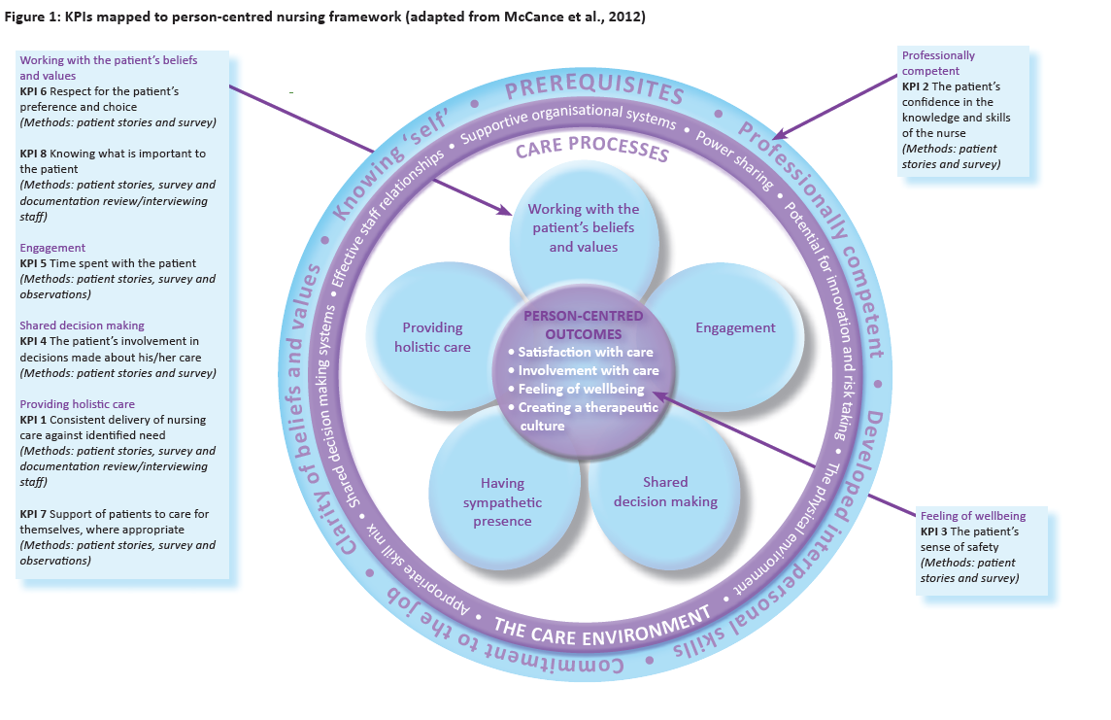

Providing holistic care – Consistent delivery of nursing care against identified need. (method: patient survey and documentation review/interviewing staff)
Professionally competent – The patient’s confidence in the knowledge and skills of the nurse. (method: patient stories and surveys)
Feeling of wellbeing – The patient's sense of safety. (method: patient stories and surveys)
Shared decision making – The patient’s involvement in decisions made about his/her care. (method: patient stories and surveys)
Engagement – Time spent with the patient. (method: patient stories and surveys and observation)
Working with patients beliefs and values – Respect for the patient’s preference and choice. (method: patient stories and surveys)
Support of patients to care for themselves, where appropriate. (method: patient stories and surveys and observation)
Knowing what is important to the patient. Method: stories, survey and documentation review/interviewing staff)
Referral criteria – The percentage of referrals received by the service meeting the criteria
Response time following referral – the percentage of patients who are seen within the following urgency categories –
Urgent ( within 2 hours)
Routine (within 24 hours)
District Nursing Team contact details – The percentage of new patients on the caseload who have clear documented contact details for their district nursing team at first contact.
GP notification of admission to team caseload – The percentage of referring practitioners who are informed that the patient has been admitted onto district nursing caseload within 48 hours of contact or assessment .
Holistic assessment completed by second visit – The percentage of new patients on the caseload who receive a holistic assessment on or following the second visit. Carer and next of kin to be documented(all exceptions to be documented with clinical rationale)
Full nursing assessment –The percentage of patients on the caseload with a full nursing assessment in place.
Patient, carer and family involvement in care plan development –The percentage of patients who reported they were involved in the development and agreement of their care plan.
Expected date of discharge from caseload – The percentage of patients who are given an estimated date of discharge upon admission to the caseload.
Care manager contact details – The percentage of patients requiring a case manager, who have their name and contact details of their case manager within a week of the first visit.
Documented case management plan – The percentage of patients on the district nursing case load with a long term condition (where the DN is the case manager) that have a clearly documented case management plan within one week of assessment.
Up to date care plans in place – The percentage of patients who have a relevant up to date care plan in place (assessments or clinical reviews underpinning any required changes should be reflected in the care plan and subject to audit)
Self-management and escalation information – The percentages of patients on the case load given self-management and escalation information in support of their treatment of condition.
Clinical Review – The percentage of patients who are subject to a clinical review with the care plan updated accordingly (C11)
Evaluation date recorded – The percentage of patients who have an evaluation date planned, updated and any changes formally documented.
Equipment ordered – The percentage of patients who are assessed and identified as requiring appropriate equipment who are prescribed within locally agreed timescales:
Urgent ( within 2 hours)
Routine (within 24 hours)
Drug and dressing bundle – Percentage of patients who have the appropriate drugs and dressing bundles as per their care plan.
Unmet needs identified – The percentage of patients whose identified needs are actioned within a locally agreed timeframe and removal combined with assessment (CN05/06)
Appropriate skill mix deployment – The percentage of patients who receive their care from the most appropriate member of the DN team, reflecting complexity and specialist skills required.
Preferred Priorities of care (PPC) – Percentage of patients who die in accordance with the PPC.
Venous leg ulcer healing rates – The percentage of venous leg ulcers fully healed within 12 weeks of assessment.
Doppler assessment – Percentage of patient with a venous leg ulcer who had a Doppler assessment.
Completion of PREM questionnaire – Percentage of patients who were offered the opportunity to complete a PREM at the point of discharge.
Self-management – The percentage of patients who reported they are confident in managing their own condition at the point of discharge.
Onward referrals to other services – The percentage of patients discharged to other statutory services.
Patients involvement in decision making and treatment planning – Percentage of patient surveyed who indicated they have been actively involved in decision making during their episode of care.
Patients reporting an EQ-5D improvement - The percentage of patients who reported an improvement in score between assessment and discharge in their condition using the EQ-5D questionnaire.
Achievement of wound care standard - The percentage of patients where wound care goals were achieved during their episode of care.
Adherence to expected date of discharge (EDoD) – the percentage of patients discharged within three days of the documented EDoD.
Delayed discharge from the case load – The percentage of patients whose discharge from the caseload was delayed.
Timely provision of discharge summary – The percentage of patients to have a discharge summary sent back to their GP within two weeks of date of discharge from a caseload.
Signposting to third sector provision post-discharge – The percentage of patients who had evidence of sign positing to third sector partners for ongoing care or additional care.
Evidence of steps taken to establish the extent to which the service provides fair access, and steps taken to improve this.

Evidence of effective efforts on maximising the person’s comfort and wellbeing using established validated outcome measures, e.g. the Integrated Palliative Outcome Scale (IPOS).

Extent to which the service provider engages with the local systems to share information that supports better coordination of care, e.g. through participation in Electronic Palliative Care Coordinating Systems (EPaCCS) or equivalent, where these exist locally

Evidence of education and training, other staff support measures and appraisal systems for own staff, and contribution to the education and training of generalist end of life care teams in the locality

Evidence of measures that the service has taken, or plans to take, in relation to community engagement and understanding of palliative and end of life care.

Location of Provider Premises
The Provider’s Premises are located within, and operating from the Southport and Formby Area

Individual Service User Placement

Appendix 1

The Principles of nursing practice tell us what patients, colleagues, families and carers can
expect from nursing. Nursing is provided by nursing staff, including ward managers (in hospitals) or team leaders (in the community), specialist nurses, community nurses, health visitors, health care assistants or student nurses.

Principle A: nurses and nursing staff treat everyone in their care with dignity and humanity – they understand their individual needs, show compassion and sensitivity, and provide care in a way that respects all people equally.

Principle B: nurses and nursing staff take responsibility for the care they provide and answer for their own judgments and actions – they carry out these actions in a way that is agreed with their patients, and the families and carers of their patients, and in a way that meets the requirements of their professional bodies and the law.

Principle C: nurses and nursing staff manage risk, are vigilant about risk, and help to keep everyone safe in the places where they receive health care.

Principle D: nurses and nursing staff provide and promote care that puts people at the centre, and involves patients, service users, their families and their carers in decisions to help them make informed choices about their treatment and care.

Principle E: nurses and nursing staff are at the heart of the communication process they assess, record and report on treatment and care, handle information sensitively and confidentially, deal with complaints effectively, and are conscientious in reporting the things they are concerned about.

Principle F: nurses and nursing staff have up to- date knowledge and skills, and use these with intelligence, insight and understanding in line with the needs of each individual in their care.

Principle G: nurses and nursing staff work closely with their own team and with other professionals, making sure patients’ care and treatment is co-ordinated, is of a high standard, and has the best possible outcome for the patient.

Appendix A – Principles of nursing practice

Principle H: nurses and nursing staff lead by example, develop themselves and other staff, and influence the way care is given in a manner that is open and responds to individual needs.

For further information on the Principles of nursing practice please visit the RCN website:
www.rcn.org.uk/

