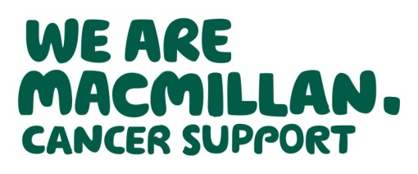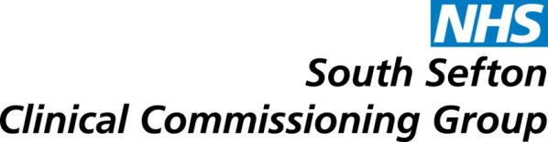

**Macmillan Information Hubs – we need YOUR help!**

Your local NHS is planning to locate four Macmillan Cancer Support Information Hubs in south Sefton as part of a pilot.

To ensure these are located in areas and venues that are right for you, we are asking local residents to tell us what they think.

**What is a community Macmillan Hub?**

* A free information and support resource for those affected by cancer including those worried about symptoms, patients, carers , their families and those close to them.
* Hubs provide a wide range of Macmillan information leaflets and free confidential support and advice delivered by a Macmillan professional.

**What is being planned?**

* To locate four hubs in established venues across south Sefton such as health centres and one stop shops.
* The areas of Sefton being considered are Bootle, Crosby, Seaforth, Litherland, Maghull and Netherton.

**How you can help?**

Please complete the attached survey and return to the FREEPOST address on the back of the survey or email to [communications@sefton.nhs.uk](mailto:communications@sefton.nhs.uk).

If you require the survey in a different format or language, please email [communications@sefton.nhs.uk](mailto:communications@sefton.nhs.uk) or call 0151 247 7000.

**Please complete and return all surveys by 22 April 2016.**

**Thank you for your support!**